**Learning Management System**



Session: 2022 – 2026

**Submitted by:**

Name: Robass Atif

Registration No: 2022-CS-150

**Submitted to:**

Mr. Nazeef-ul-Haq

Department of Computer Science

**University of Engineering and Technology**

**Lahore Pakistan**

Contents

Figures: 2

• **Indroduction** 3

• Project Schema 3

• Explain Schema 4

• Entities and Attributes: 4

• UI Pages 5

• Data Flow Diagram 8

• Conclusion 9

## Figures:

Figure 1 Learning Management System 6

Figure 2 Add Student 6

Figure 3 Student Result 7

Figure 4 Add CLO 7

Figure 5 Add Rubric Level 8

# **Indroduction**

The Learning Management System (LMS) project is designed to cater to the needs of educational institutions, particularly in managing various aspects of student assessments, attendance records, course learning outcomes (CLOs), and student information and results. The project encompasses several key tables, including Assessment, AssessmentComponent, ClassAttendance, Clo, Lookup, Rubric, RubricLevel, Student, StudentAttendance, and StudentResult. The Assessment table stores details about different assessments, such as their IDs, titles, creation dates, total marks, and weightage. AssessmentComponent table contains information about the different components of each assessment, including their IDs, names, rubric IDs, total marks, creation dates, and updated dates.

ClassAttendance is utilized to track attendance records for each class session, while Clo table holds information about course learning outcomes like their names, creation dates, and updated dates. The Lookup table functions as a generic storage for lookup values across various categories.The Rubric table defines assessment rubrics, containing details such as rubric IDs, details, and associated CLO IDs. RubricLevel table provides information about the different measurement levels within a rubric.The Student table stores individual student information, including IDs, first names, last names, contact details, email addresses, registration numbers, and status (active or inactive). StudentAttendance table tracks attendance records for individual students, while StudentResult table stores evaluation results for each student pertaining to specific assessment components, including rubric measurement IDs and evaluation dates.This C# .NET Framework application is deemed necessary because managing data manually is not secure and risks data loss. Using a database resolves this issue, providing secure and concurrent access for multiple users.

The application facilitates easy management, searching, and sorting of student records and course learning outcomes. Administrators can manage rubrics, add rubric levels, and enforce restrictions on duplicate additions. Assessments and assessment components can be easily managed and used for student evaluations.Furthermore, administrators can mark student attendance and download various reports for administrative purposes. They also have the ability to change student statuses from active to inactive and vice versa.

In summary, the project is tailored to meet the specific needs of the Department of Computer Science at UET Lahore, focusing on streamlining assessment processes, monitoring student attendance, and evaluating student performance based on predefined rubrics and learning outcomes.

# Project Schema

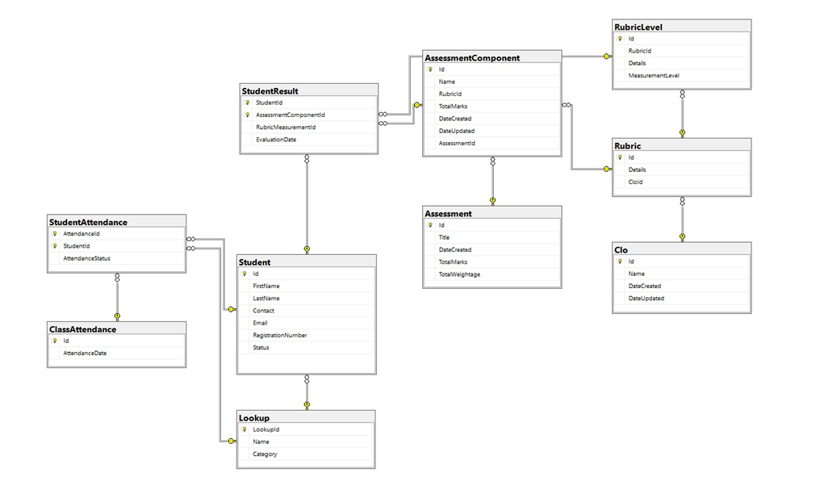

# Explain Schema

## Entities and Attributes:

* + **StudentResult**:
    - Attributes: StudentId, AssessmentComponentId, RubricLevelMeasuredId, EvaluationDate
  + **AssessmentComponent**:
    - Attributes: Id, Name, RubricId, TotalMarks, DateCreated, DateUpdated, AssessmentId
  + **RubricLevel**:
    - Attributes: ID, RubricId, Details, MeasurementLevel
  + **CLO (Course Learning Outcome)**:
    - Attributes: ID, Name, DateCreated, DateUpdated
  + **Rubric**:
    - Attributes: ID, Details, CLOid
  + **Assessment**:
    - Attributes: ID, Title, TotalMarks, DateCreated, TotalWeightage
  + **Lookup**:
    - Attributes: LookupId, Name, Category
  + **Student**:
    - Attributes: Id, FirstName, LastName, Contact, Email, RegistrationNumber, Status
  + **StudentAttendance**:
    - Attributes: StudentId, AttendanceStatus, AttendanceDate
  + **ClassAttendance**:
    - Attributes: AttendanceStatus, AttendanceDate
* **Relationships**:
  + **StudentResult** relates to **AssessmentComponent**, **RubricLevel**, and **Student**.
  + **AssessmentComponent** is associated with **Rubric** and **Assessment**.
  + **RubricLevel** is connected to **Rubric**.
  + **CLO** has a relationship with **Rubric**.
  + **Assessment** is linked to **Lookup**.
  + **Student** has relationships with **StudentAttendance** and **ClassAttendance**.
* **Cardinality**:
  + The cardinality (relationship multiplicity) isn’t clearly visible in the image due to resolution limitations. However, it’s essential for understanding how many instances of one entity can be related to another. For instance:
    - One student can have multiple student results.
    - An assessment component can be associated with multiple rubrics.
    - A rubric level corresponds to one rubric.
    - A CLO can be linked to multiple rubrics.
    - An assessment can have various lookup values.
    - Each student may have attendance records.

# UI Pages

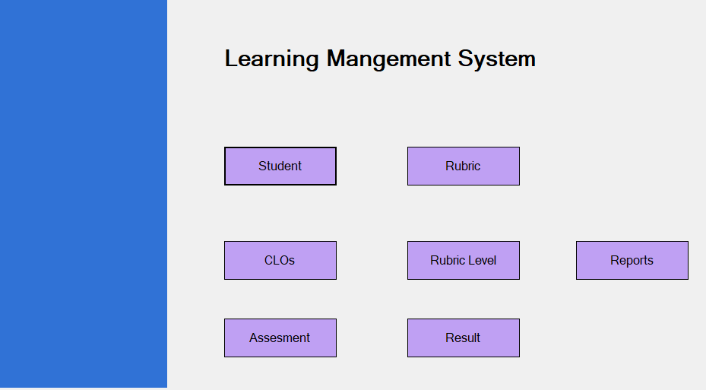

Figure Learning Management System

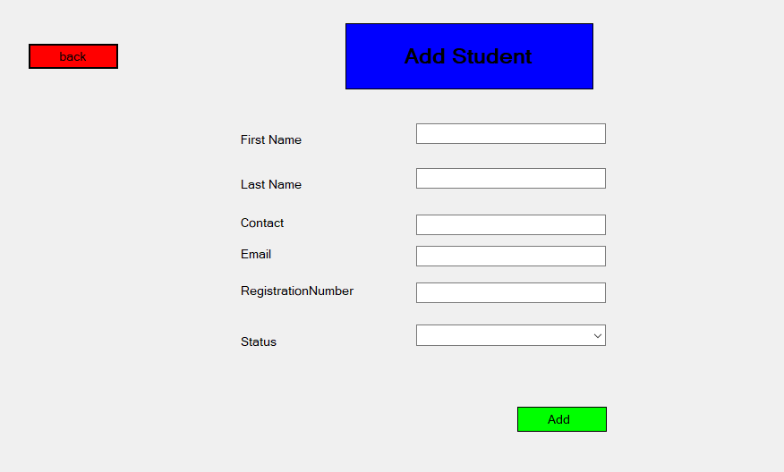

Figure Add Student

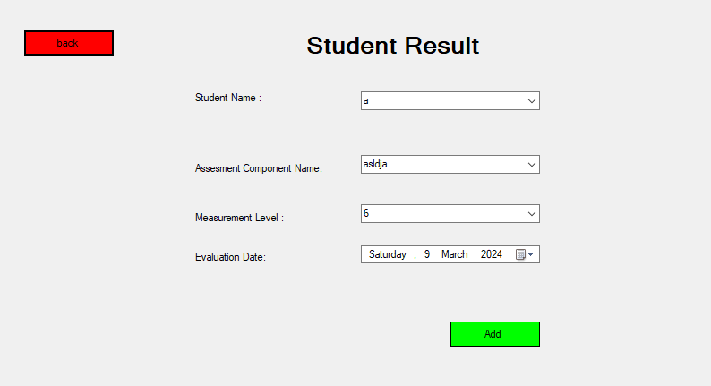

Figure Student Result

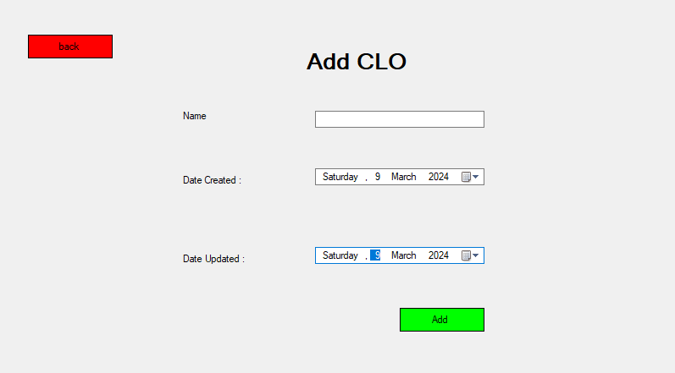

Figure Add CLO

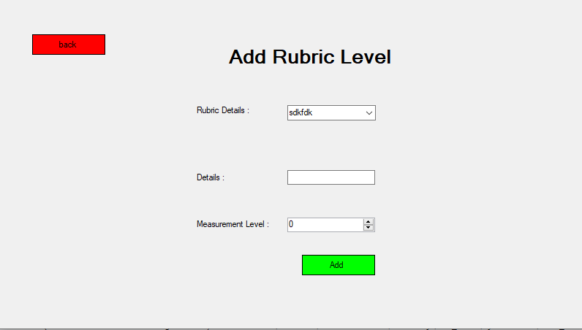

Figure Add Rubric Level

# Data Flow Diagram

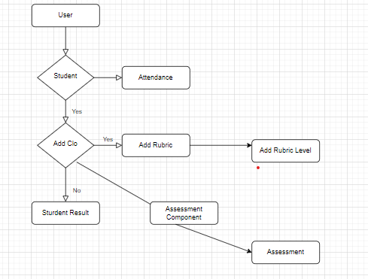

# Conclusion

In conclusion, the Learning Management System (LMS) project serves as a comprehensive solution for educational institutions, particularly tailored to the Department of Computer Science at UET Lahore. By efficiently managing student assessments, attendance records, and course learning outcomes through a secure database-driven application, it enhances administrative efficiency and ensures a streamlined approach to student evaluation and performance monitoring.